AWS Landing Zone Accelerator

Overview
The Landing Zone Accelerator on AWS (AWS LZA) solution deploys a foundational set of capabilities that is designed to align with AWS best practices and multiple global compliance frameworks. With this AWS Solution, you can better manage and govern your multi-account environment that have highly-regulated workloads and complex compliance requirements. When used in coordination with other AWS services, it provides a comprehensive, low-code solution across more than 35 AWS services.
The Version 1 implementation of the AWS LZA will align with CIS 1.2.0 and AWS Best Practices for Security, Identity & Compliance.
The AWS LZA is deployed via CloudFormation and utilises AWS Code Pipeline to deploy most components using CDK, the implementer must enable AWS Organisations & AWS Control Tower before deployment.
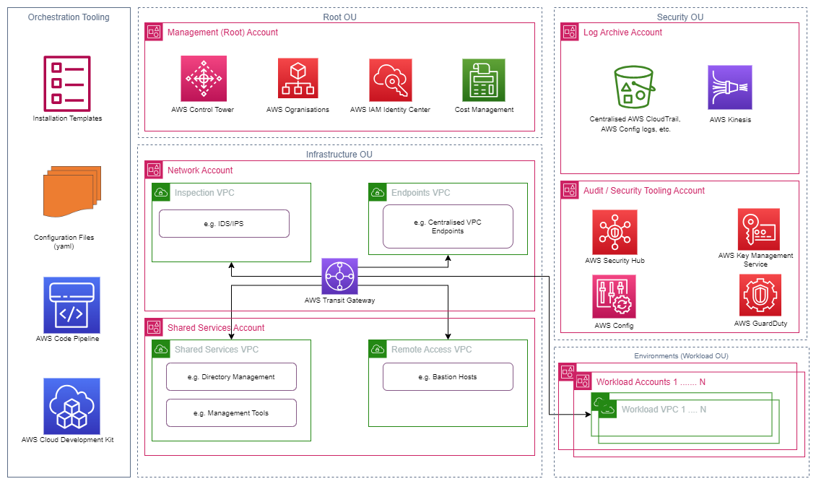
Diagram showing the default Version 1 deployment of the AWS LZA with suggested placement of services

Technical Details
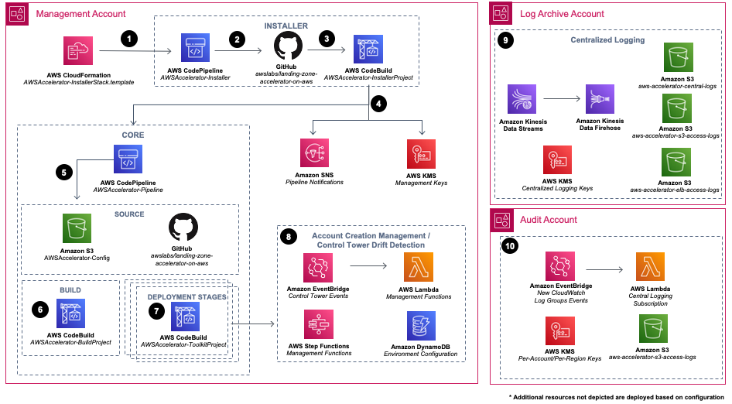
- You can use AWS CloudFormation to install this solution into your environment. Your environment must meet prerequisites prior to deploying the solution. The provided CloudFormation template will deploy an AWS CodePipeline that contains the Landing Zone Accelerator on AWS installation engine.

- The Installer pipeline deploys the solution’s Core features. Because this installer functions separately from the Core solution infrastructure, you can update to future versions of the solution with a single parameter through the CloudFormation console.

- An AWS CodeBuild project functions as an orchestration engine to build and execute the solution’s AWS Cloud Development Kit (AWS CDK) application that deploys CloudFormation stacks across each of this solution’s managed AWS accounts and Regions.

- The solution deploys Amazon Simple Notification Service (Amazon SNS) topics that you can subscribe to for alerts on core pipeline events, which can increase observability of your Core pipeline operations. Additionally, the solution deploys two AWS Key Management Service (AWS KMS) customer-managed keys to manage encryption at rest of Installer and Core pipeline dependencies.
- An AWS CodeBuild project functions as an orchestration engine to build and execute the solution’s AWS Cloud Development Kit (AWS CDK) application that deploys CloudFormation stacks across each of this solution’s managed AWS accounts and Regions.

- A CodeBuild project compiles and validates the solution’s AWS CDK application configuration.

- Multiple CodeBuild deployment stages deploy the resources that were defined in the solution configuration files to your multi-account environment. An optional manual review stage may be included, allowing you to view all the changes that these stages will apply.

- The solution deploys resources that monitor AWS Control Tower lifecycle events to detect potential drift against a known good state (in other words, when the actual configuration of an infrastructure resource differs from its expected configuration). The solution also deploys resources that can automate the enrollment of new AWS accounts into your multi-account environment.

- The solution deploys centralized logging resources in the Log Archive account in your multi-account environment. This includes Amazon Kinesis resources to stream and ingest logs, AWS KMS keys to facilitate encryption at rest, and Amazon S3 buckets as log storage destinations.

- The solution provisions the audit account with resources to stream Amazon CloudWatch log groups to the centralized logging infrastructure in the Log Archive account.

Further Reading:
Landing Zone Accelerator on AWS | AWS Solutions | AWS Solutions Library (amazon.com)
Security, Identity & Compliance | AWS Architecture Center (amazon.com)
AWS LZA Deployment Guide.docx

